NAAN MUDHALVAN ARTS INTERNSHIP PROGRAM 2026
Frontend Web Development using React
Project Submission Template

STUDENT NAME: Deepika A
YEAR:2024-2027
COLLEGE CODE: asbruap
COLLEGE NAME: PPG COLLEGE OF ARTS AND SCIENCE
DEPARTMENT: IT
SEMESTER: V
ROLL NO: 2426j0080
NMID: asbruap2426j0080
DATE: 19-06-2026
TITLE: Trainer Session Attendance Dashboard
GITHUB LINK : https://github.com/24bscit006cas-star

1.ABSTRACT

The Trainer Session Attendance Dashboard is a React-based web application designed to help training managers track and manage student attendance across multiple training batches. The system allows trainers to mark daily attendance, view attendance records batch-wise, filter attendance by date, and calculate attendance percentages. The dashboard provides an organized and user-friendly interface for efficient attendance management.

PROBLEM STATEMENT

Training managers often face difficulties in maintaining attendance records manually across different batches and training sessions. Manual tracking can lead to errors, data loss, and inefficient reporting. A centralized attendance dashboard is needed to simplify attendance management and improve accuracy.

OBJECTIVES

• Build a responsive attendance management dashboard.
• Mark student attendance as Present or Absent.
• View attendance records batch-wise.
• Filter attendance by specific dates.
• Calculate attendance percentages automatically.
• Generate attendance summaries and reports.

PROJECT SCOPE

The application supports attendance tracking for multiple training batches, attendance filtering, attendance percentage calculation, and dashboard statistics. Future enhancements may include authentication, cloud database integration, report exports, and notification systems.

TECHNOLOGIES USED

• React.js
• TypeScript
• Vite
• HTML5
• CSS3
• React Context API
• Local Storage
• React Router
• Git & GitHub

APPLICATION FLOW

- User opens the dashboard.
- User selects a training batch.
- User marks attendance for students.
- Attendance data is saved and displayed.
- User filters attendance records by date.
- Dashboard calculates attendance percentages.
- Attendance reports and statistics are displayed.

KEY REACT CONCEPTS USED

• Components
• Props
• State Management
• Context API
• React Hooks
• Routing
• Conditional Rendering
• Form Handling

EXPECTED OUTPUT

A user-friendly dashboard where training managers can:
- Mark attendance efficiently.
- Track attendance across multiple batches.
- View attendance percentages.
- Filter records by date.
- Generate attendance summaries for better decision-making.

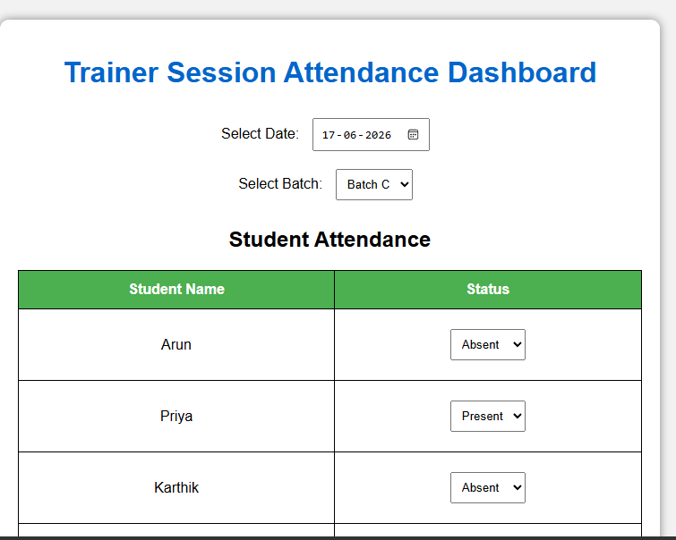

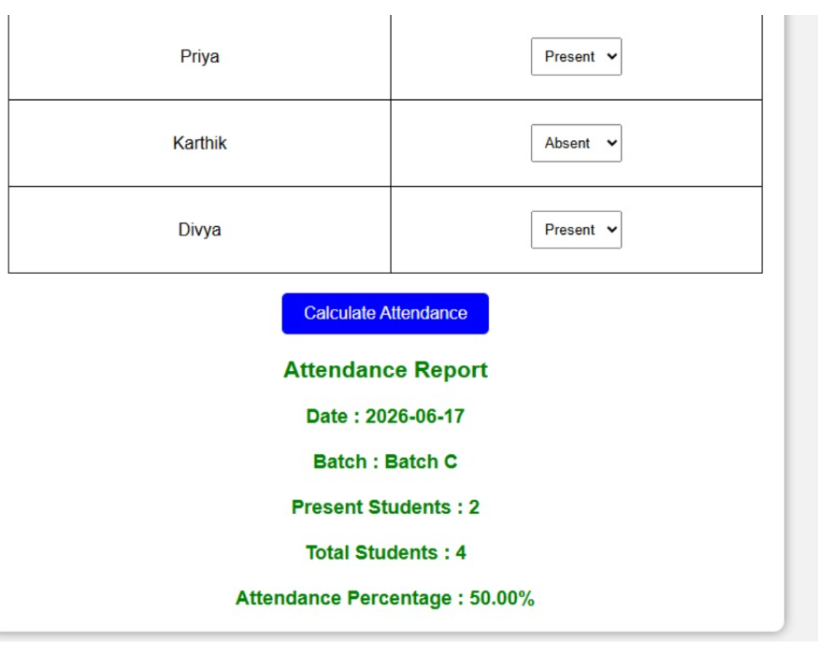

CHALLENGES FACED

- Managing attendance data across batches.
- Implementing date-wise filtering.
- Calculating attendance percentages accurately.
- Maintaining data persistence using local storage.
- Designing a responsive dashboard UI.

LEARNING OUTCOMES
• React and TypeScript development.
• State management using Context API.
• CRUD operations implementation.
• Attendance data handling and calculations.
• Routing and component-based architecture.

CONCLUSION

The Trainer Session Attendance Dashboard provides an effective solution for managing student attendance in training programs. The project demonstrates practical React development skills while improving attendance tracking, reporting, and overall training management efficiency.

